Listening
SKILLS TEST 3
1 Listen and write the times you hear.  ⁰⁸
/ 5
1 1 o’clock 2 o’clock 3 o’clock
4 o’clock 5 o’clock 6 o’clock
2 Listen and draw  or  . ⁰⁹
/ 4
/ 3
likes = doesn’t like =
1 |  | 2   |  | 3 |  | 4 |  | 5 | 
Reading
3 Read and draw the times.
/ 5
My name’s Lily. I get up at six o’clock in the morning. I have breakfast at seven o’clock with my mom and my brother. I like eggs for breakfast. My brother likes bread and jelly! I go to school at eight o’clock. I like math and P.E. I play with my friends in the school yard every day. We have lunch at one o’clock. I have sandwiches and a banana or an apple. I go home at four o’clock. I do my homework then I have dinner at six o’clock.

1 | 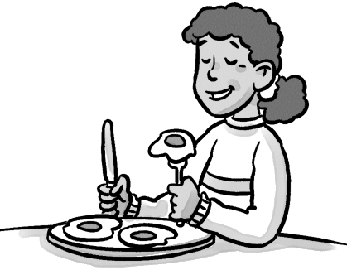 | 2 | 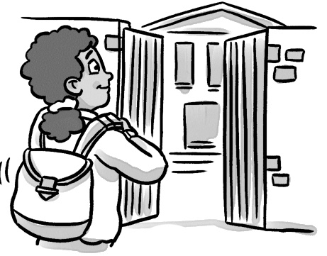 | 3 | 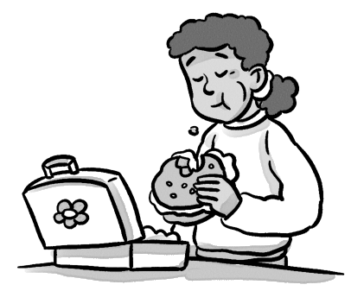 | 4 | 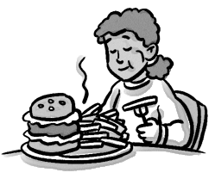
4 Read again and write T (true) or F (false).
1 Lily gets up at seven o’clock. 
F
2 She has breakfast with her dad.
3 She likes eggs for breakfast.
4 She doesn’t like P.E.
5 She has sandwiches for lunch.
6 She has dinner at eight o’clock.
Writing
5 Look and complete the sentences.
likes = doesn’t like =

1 Lia likes candy.  2 Lia presents.  3 Lia balloons.  4 Tanya presents.  5 Tanya balloons.  6 Tanya candy. |  | Lia | Tanya
 | 
 | 

6 Complete the sentences.
/ 5
/ 4
/ 5
1 | 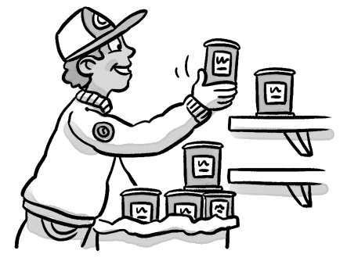 | 2 | 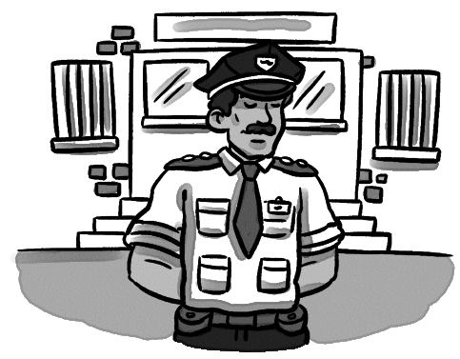 | 3 | 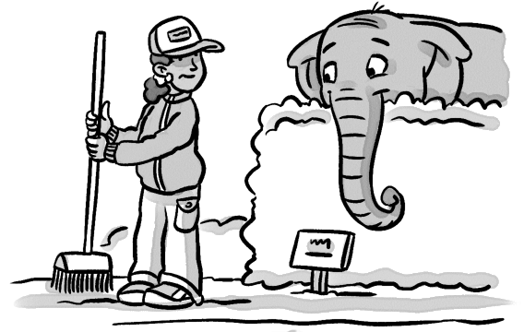 | 4 | 
1 He works in a store . 2 in a .
3 in a . 4 in an .
Speaking
/ 3
7 Look and say.
/ 30
1 | 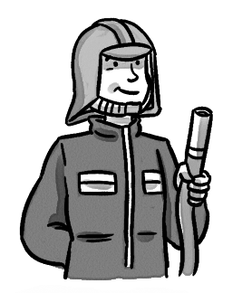 | 2 | 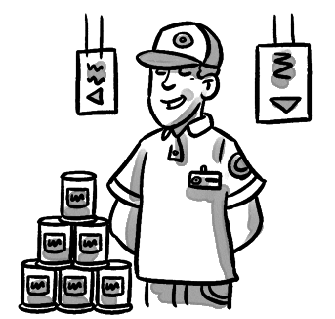 | 3 |  | Does he…  No, he doesn’t.  1 work in a bank?  2 work in a zoo?  3 work in an airport?  Does she…  4 work in a hospital  5 work in a zoo?  6 work in a police station?
4 | 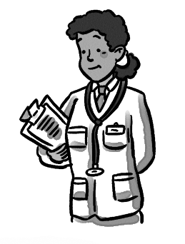 | 5 | 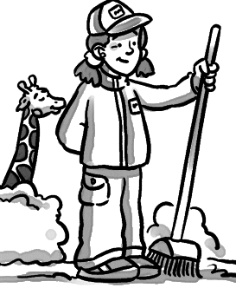 | 6 | 